Test Scenario With Test Case - ExcelSycnapp
1]
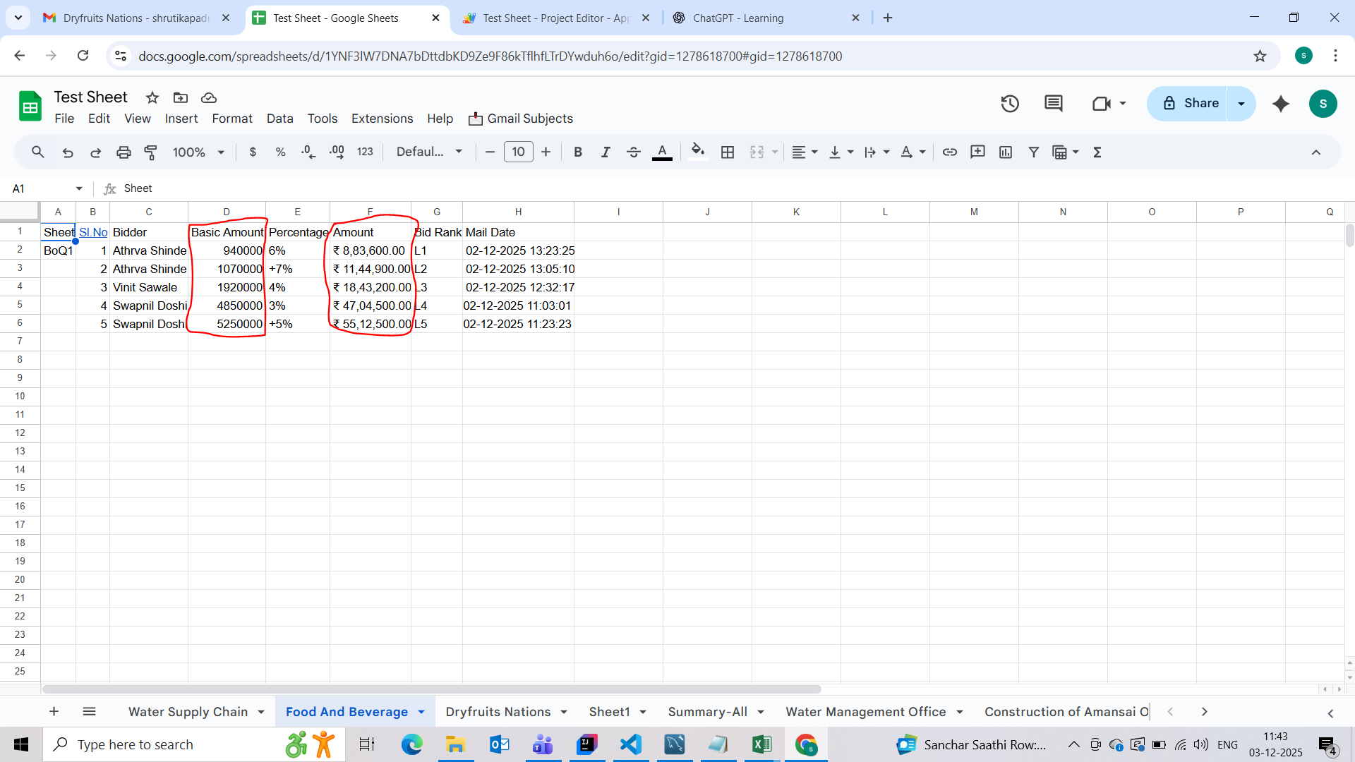

- Basic Amount should be Fix. Ex. If Total in Fig 500000 that means its shows 500000.
- Amount should be percentile.
- Percentages should have - /+ Symbols .here, they are shuffles.
- Rank should be displays L1 to L5, L6….. so on. Sometimes they shows excess OR same rank.

2]
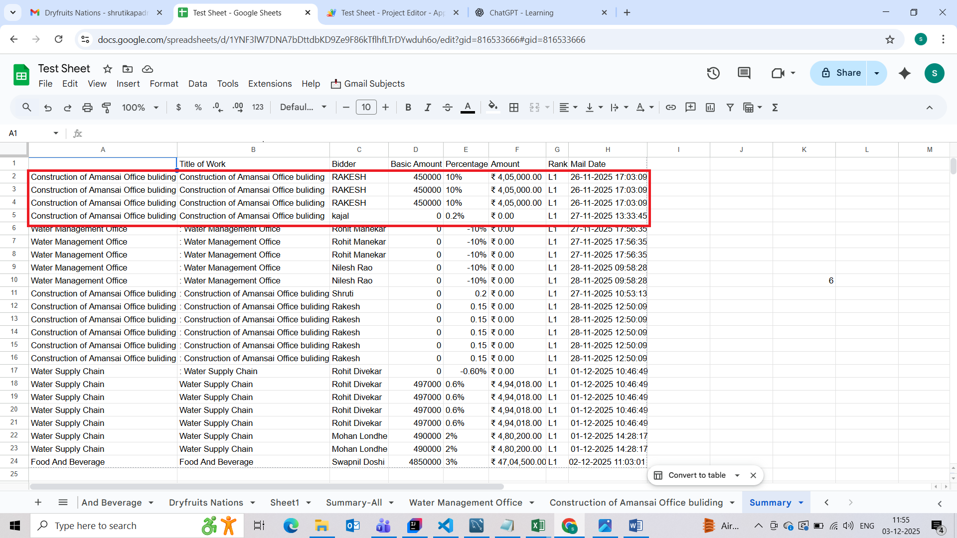

- Here, Multiple Entries are Shows. Multiple entries should not be shows.
- Percentages column should be arrange.

